Auto Balancing De Sauty Bridge for Differential Capacitive Sensing

Subtitle as needed (*paper subtitle*)

Authors Name

line 1 (of *Affiliation 1*): dept. name of organization, City, Country

line 2: (of *Affiliation 2*): dept. name of organization, City, Country

line 4: e-mail address if desired

*Abstract*— An analog interface is proposed to estimate capacitance variation, by measuring differential capacitance. A modified De-Sauty bridge consisting of two differential capacitors and two resistors one of which is a voltage-controlled resistor is auto-balanced using Arduino Uno as a PI controller, giving an evaluation of differential capacitance variation. Unlike other works in literature, the electronic interface and feedback mechanism provides a linear input-output characteristic. The interface proposed shows a relative percentage error within 1.50% for the experimental results.

Keywords— Differential capacitance sensor, bridge-based circuit, Arduino, PI controller.

# Introduction

Capacitive sensor measures change in capacitance, due to variation in overlapping area, permittivity or distance between the plates. Hence they are suitable for measuring the chemical as well as physical quantities at low cost [1-6]. Capacitive sensing can be achieved by conversion of capacitance-to-current, capacitance-to-phase, capacitance-to-frequency, capacitance-to-voltage etc. Differential capacitive sensors show improved common mode rejection and are suitable for measurement of small capacitance variation [7]. Position sensors [8] and accelerometers [9] are few of the application areas where differential capacitance measurement is employed.

Measurement of small differential capacitance in presence of large stray capacitance is a challenging task. Capacitance bridge circuits in open loop configuration [2] are often used for such sensors. Another approach is the measurement of capacitance by bridge auto-balance[10-12], it is basically a closed loop approach for measurement and thus effect of parameter variation etc. can be reduced considerably. In one such method [10] used a modified De-Sauty bridge (with bridge element comprising of two capacitors and two resistors) using an analog interface circuit.

In the present work, an arduino microcontroller is employed which computes the error voltage and acts as a controller for bridge auto balance using a Voltage Control Resistor. The major advantage of the proposed scheme is the simplicity, use of microcontroller for autobalance and the flexibility of controller tuning; at the same time direct availability of read out data.

# DIFFERENTIAL CAPACITIVE SENSOR: AN OVERVIEW

Two structures of differential capacitive sensors are depicted in in Fig. 1, consisting of a three-plate capacitive system out of which two plates are fixed and the third is movable; change in capacitance is caused due to change in geometric parameters. In Fig. 1(a) perturbation changes the distance between plates, whereas in Fig. 1(b), the overlapping area between plates changes.

For Fig.1 the position of the movable plate relative to the fixed plate (A and B), can be referred in terms of a dimensionless variable x. For the central position x=0, and for the extreme positions, x= ±1. The capacitances $C_{1}$  and $C_{2}$   when expressed in terms of parameter x [10], for plate distance variation (1) and overlapping area variation (2), respectively

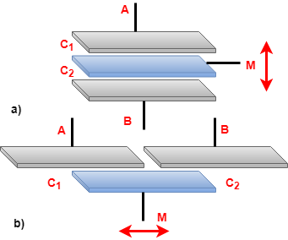

Fig. 1. Methods of differential capacitive sensing (a) when perturbation changes the distance between the plates and (b) when perturbation changes the overlapping area.



Where $C_{0}$  is the capacitance for x=0. From the equations, it is clear that both the capacitance varies in a complementary manner with respect to perturbation. A differential capacitive system measures the difference between the capacitance rather than their absolute value. For both the configuration in Fig. 1, x can be expressed by (3), which depends on the absolute value of capacitance.



# PROPOSED APPROACH

A modified De-Sauty AC bridge whose right branch consists of Voltage Controlled Resistor (VCR) and a fixed resistance ( $R_{b})$ and the left one consists of differential capacitive sensor $(C_{1},C_{2})$ as shown in Fig. 2, is employed for capacitance-to-voltage conversion in continuous time. The evaluation of the differential capacitance variation is done through tuning of VCR, by the feedback loop which handles the bridge output.

The proposed interface combines the advantages of two basic electronic circuits, the bridge-based framework and the differential capacitance into a single architecture. Autobalancing of bridge by tuning VCR increases the estimated range of the circuit, while the resolution problem due to common mode disturbance is solved by using differential capacitance.

The capacitive sensor is excited by a sinusoidal signal $V_{m}sin⁡(ωt)$ and the sensor output $V_{s}(t)$ is also sinusoidal. The dependence of sensor output on the relative position x is given by (4)

$V_{s}\left(t\right)=\left(x+1\right)\frac{V_{m}\sin\left(ωt\right)}{2}$ (4)

Auto balancing of the bridge can be interpreted as a negative feedback system. Where the error voltage is nullified by a PI controller. The input and output are related by the feedback gain only. The prototype of the implementation is shown in Fig. 4, each functional block of the feedback system proposed, comprises of discrete components.

The differential capacitive sensor is excited by ac input, for x=0, $V_{s}\left(t\right)=\frac{V_{m}\sin\left(ωt\right)}{2}=V_{ref}(t)$ and for xϵ[1,-1], $\left|V_{s}\left(t\right)\right|ϵ[0,V_{m}]$, following (4). The voltage across the VCR, $V_{fb}$ is controlled such that it follows $V_{s}$. The VCR is implemented by analog multiplier AD633 [11], where the voltage across VCR is given by,

 (5)

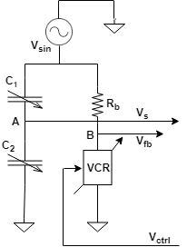

Fig. 2. Bridge auto-balance by a feedback loop.

At the balance position, $V_{fb}$ equals $V_{s}$, hence equating (4) and (5), we get the relation:

$\frac{\left(x+1\right)V_{m}\sin\left(ωt\right)}{2}=V_{ref}(t)(\frac{V_{ctrl}}{10\left[V\right]}+1)$ (6)

As $V_{ref}=\frac{V_{m}\sin\left(ωt\right)}{2}$, we get

 (7)

Accurate estimation of measurand x can be obtained by (7).

The $V_{ctrl}$ is generated by the pulse width modulation pin of the Arduino Uno microcontroller. Each of $V_{s}$ and $V_{fb}$ sinusoidal ac signal is converted to its respective dc voltage, by passing through a full-wave precision rectifier (refer Fig. 5) followed by a RC low pass filter. The dc signals are fed to the analog input pins of the microcontroller. The microcontroller implements the feedback summing node as well as PI controller (refer Fig. 3).

The VCR has two differential inputs (refer Fig. 6), one of which is connected to node B of Fig. 2 and other is fed $V_{ctrl}$, that can vary from 0 V to 5 V, as the maximum output of the microcontroller is 5 V. For x=0, $V_{ctrl}$ =2.5V and for $xϵ[-0.25,0.25]$, $V_{ctrl}$ ϵ [0,5] V. Given by,

 (8)

Here,  and  are proportional constant and integral constant respectively, the value of which determines the characteristics of the system. The proportional control is proportional to the error voltage and increases the speed of the response, while the integral control reduces the steady state error to zero.

## 

Fig. 3. Generic schematic of an autobalancing system.

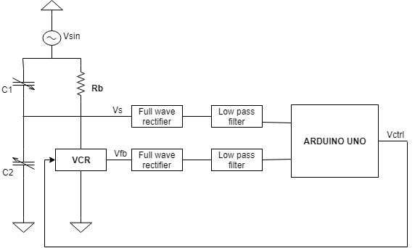 Fig. 4. Schematic of the interface proposed.

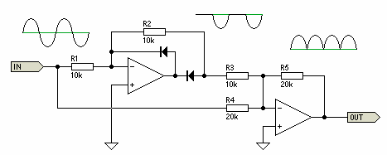

Fig. 5. Full wave precision rectifier circuit.

# Result and Discussion

For the bridge based front end, the value of is 10 KΩ and VCR is 10 KΩ for =0V. At this value of , we have chosen , so the effect due to parasitic capacitance can be neglected. For the RC low pass filter, the value of R and C are chosen to be 10 KΩ and 10µF respectively.

In the autobalancing range, a discrete component board is used to carry out the measurement,  is used to determine the value of x following (7). The range onis limited to 0 to 5 V. Therefore, the useful range of xϵ [-0.25,0.25]. An oscilloscope has been employed to measure the output of the differential capacitance and a digital multimeter to measure , so as to get an accurate value of x. The percentage relative error comes out to be less than 1.5% as shown in Fig. 7. Table I presents a comparison between different interface result reported in literature. And the proposed approach shows good accuracy comparatively.

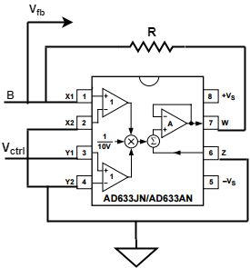

Fig. 6. Voltage Controlled Resistor circuit.

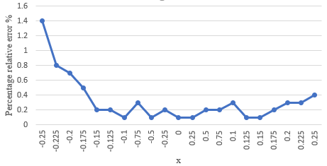

Fig. 7. Percentage relative error vs. x.

1. Compasison Table

|  |  |  |  |  |
| --- | --- | --- | --- | --- |
| **Reference** | [12] | [13] | [14] | This Work |
| **Topology** | Discrete | Discrete | Discrete | Discrete |
| **Capacitance[F]** | 500p (±50%) | 200-1200p | 25-840 n (±100%) | 200 p  (±25%) |
| **Approach** | C to V | C to V | C to V | C to V |
| **Error** | ±0.03% | <6% | <10% | <1.5% |

# Conclusion

In this paper a modified scheme for auto-balancing De-Sauty bridge for differential capacitance sensing is proposed. The novelty of the proposed work is the use of a microcontroller that significantly reduces the complexity of the analog interface. It is also possible to customize the system and change the system parameters by changing the value of proportional and integral constants. Preliminary experimental results show fairly good accuracy and consistency compared to the existing techniques. Considerable improvement is expected by using a shielded capacitor and PCB instead of a breadboard. The major drawback of this method is that capacitance estimation is possible only in quarter range.

##### References

1. A. De Marcellis and G. Ferri, Analog Circuits and Systems for Voltage-Mode and Current-Mode Sensor Interfacing Applications. Dordrecht, The Netherlands: Springer, 2011.
2. L. K. Baxter, “Capacitive sensor basics,” in Capacitive Sensors: Design and Applications. New York, NY, USA: Inst. Elect. Electron. Eng., 1997, pp. 1–46.I. S. Jacobs and C. P. Bean, “Fine particles, thin films and exchange anisotropy,” in Magnetism, vol. III, G. T. Rado and H. Suhl, Eds. New York: Academic, 1963, pp. 271–350.
3. J. C. Lotters, W. Olthuis, P. H. Veltink, and P. Bergveld, “A sensitive differential capacitance to voltage converter for sensor applications,” IEEE Trans. Instrum. Meas., vol. 48, no. 1, pp. 89–96, Feb. 1999.
4. T. Zeng et al., “A capacitive sensor for the measurement of departure from the vertical movement,” IEEE Trans. Instrum. Meas., vol. 65, no. 2, pp. 458–466, Feb. 2016.
5. F. Reverter and Ò. Casas, “Direct interface circuit for capacitive humidity sensors,” Sens. Actuators A, Phys., vol. 143, no. 2, pp. 315–322, 2008.
6. C. Falconi et al., “Electronic interfaces,” Sens. Actuators B, Chem., vol. 121, no. 1, pp. 295–329, 2007.
7. R. Puers, “Capacitive sensors: When and how to use them,” Sens. Actuators A, Phys., vols. 37–38, pp. 93–105, Jun./Aug. 1993.
8. M. N. Horenstein, J. A. Perreault, and T. G. Bifano, “Differential capacitive position sensor for planar MEMS structures with vertical motion,” Sens. Actuators A, Phys., vol. 80, pp. 53–61, Mar. 2000.
9. T. Tsuchiya and H. Funabashi, “A z-axis differential capacitive SOIaccelerometer with vertical comb electrodes,” Sens. Actuators A, Phys., vol. 116, no. 3, pp. 378–383, 2004.
10. Alessandro Depari, Alessandra Flammini, Vincenzo Stornelli, “Autobalancing analog front end for full-range differential capacitive sensing,” IEEE Transactions on Instrumentation and Measurement,2018; 67,pp. 885-893
11. G. Ferri, V. Stornelli, F. R. Parente, G. Barile, “Full range analog wheatstone bridge-based automatic circuit for differential capacitive sensors evaluation,” International Journal of Circuit Theory and Applications, October 2016,45,2149-2156.
12. Mantenuto P., De Marcellis A., Ferri G., “Novel Modified De-Sauty Autobalancing Bridge-Based Analog Interfaces for Wide-Range Capacitive Sensor Applications”, IEEE Sensors Journal, 2014; 14(5), pp.1664-1672.
13. Analog Devices, Norwood, MA, USA. Datasheet, AD633, Low Cost Analog Multiplier. [Online]. Available: www.analog.com/media/en/technical./data-sheets/AD633.pdf, 2011.
14. George, B., Kumar, V. J., Switched capacitor signal conditioning for differential capacitive sensors, IEEE Trans. on Instrumentation and Measurement, 2007; 56, pp. 913-917.
15. Lopez-Martin, A.J., Zuza, M., Carlosena, A. , A CMOS interface for resistive bridge transducers, IEEE International Symposium on Circuits and Systems ISCAS, 2002; 391 , pp. 153–156.
16. Van der Goes, F.M.L. , Meijer, G.C.M. , A simple accurate bridge-transducer interface with continuous autocalibration, IEEE Transactions on Instrumentation and Measurement,1997; 46, pp. 704–710.